Software Requirements Specification

for

Personnel Management System

April 14, 2023

Table of Contents

Revision History ii

1. Introduction 1

1.1 Purpose 1

1.2 Document Conventions 1

1.3 Project Scope and Product Features 1

1.4 References 1

2. Overall Description 1

2.1 Product Perspective 1

2.2 User Classes and Characteristics 2

2.3 Operating Environment 3

2.4 Design and Implementation Constraints 3

2.5 Assumptions and Dependencies 3

3. System Features 3

3.1 Order Meals from Cafeteria 3

3.1.1 Description 3

3.1.2 Functional Requirements 3

3.2 Order Meals from Restaurants 5

3.3 Create, View, Modify, and Delete Meal Subscriptions 5

3.4 Create, View, Modify, and Delete Cafeteria Menus 5

4. Data Requirements 6

4.1 Logical Data Model 6

4.2 Data Dictionary 6

4.3 Reports 9

4.3.1 Ordered Meal History Report 9

4.4 Data Integrity, Retention, and Disposal 9

5. External Interface Requirements 10

5.1 User Interfaces 10

5.2 Software Interfaces 10

5.3 Hardware Interfaces 10

5.4 Communications Interfaces 10

6. Quality Attributes 11

6.1 Usability Requirements 11

6.2 Performance Requirements 11

6.3 Security Requirements 11

6.4 Safety Requirements 11

6.5 Availability Requirements 11

6.6 Robustness Requirements 11

Appendix A: Analysis Models 12

Revision History

|  |  |  |  |
| --- | --- | --- | --- |
| **Name** | **Date** | **Reason For Changes** | **Version** |
| Karl Wiegers | 8/15/13 | initial draft | 1.0 draft 1 |
| Karl Wiegers | 9/28/13 | baseline following changes after inspection | 1.0 approved |

# Introduction

## Purpose

This SRS describes the functional and nonfunctional requirements for software Personnel Management System (PMS). This document is intended to be used by the members of the project team who will implement and verify the correct functioning of the system.

## Document Conventions

|  |  |  |
| --- | --- | --- |
|  |  |  |
|  |  |  |

## Project Scope

The PMS will enable company X to easily manage employee attendance and salary

## Product Perspective

The PMS is a software designed to help companies easily track employee attendance. It also manages employee salaries and information, as well as candidate information. Future updates are expected to introduce more advanced features to manage various aspects of employees.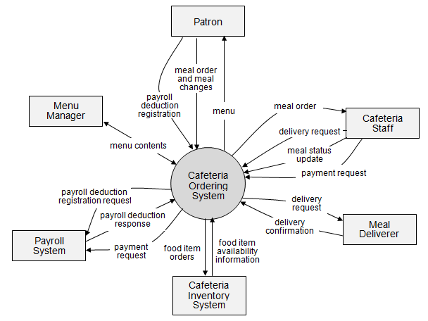

Figure 1. Context diagram for release 1.0 of the Cafeteria Ordering System.

# Overall Description

## Software Feature

[Details are not provided in this example. Quite a lot of the functionality described under 3.1 Order Meals from Cafeteria could likely be reused, so this section should just specify the additional functionality that addresses the restaurant interface.]

## Main Function

[Details are not provided in this example.]

# Functional Requirements

## User Classes and Characteristics

|  |  |
| --- | --- |
| HR | A Patron is a Process Impact employee who wants to order meals to be delivered from the company cafeteria. There are about 600 potential Patrons, of which 300 are expected to use the COS an average of 5 times per week each. Patrons will sometimes order multiple meals for group events or guests. An estimated 60 percent of orders will be placed using the corporate Intranet, with 40 percent of orders being placed from home or by smartphone or tablet apps. |
| Accountant | The Process Impact cafeteria employs about 20 Cafeteria Staff, who will receive orders from the COS, prepare meals, package them for delivery, and request delivery. Most of the Cafeteria Staff will need training in the use of the hardware and software for the COS. |
|  | The Menu Manager is a cafeteria employee who establishes and maintains daily menus of the food items available from the cafeteria. Some menu items may not be available for delivery. The Menu Manager will also define the cafeteria’s daily specials. The Menu Manager will need to edit existing menus periodically. |
| Board of Director | hhhhhhhhhhhhhhhhhhhhhhhhhhhhhhhhhhhhhhhhhhhhhhhhhhhhhhhhhhhhhhhhhhhhhhhhhhhhhhhhhhhhhhhhhhhhhhhhhhhhhhhhhhhhhhhhhhhhhhhhhhhhhhhhhhhhhhhhhhhhhhhhhhhhhhhhhhhhhhhhhhhhh |
| Admin | As the Cafeteria Staff prepare orders for delivery, they will issue delivery requests to a Meal Deliverer's smartphone. The Meal Deliverer will pick up the food and deliver it to the Patron. A Meal Deliverer’s other interactions with the COS will be to confirm that a meal was (or was not) delivered. |

## Use case diagram

### Description

A cafeteria Patron whose identity has been verified may order meals either to be delivered to a specified company location or to be picked up in the cafeteria. A Patron may cancel or change a meal order if it has not yet been prepared. Priority = High.

### Functional Requirements

|  |
| --- |
| **Order.Place: Placing a meal order**  .Register: The COS shall confirm that the Patron is registered for payroll deduction.  .No: If the Patron is not registered for payroll deduction, the COS shall give the Patron options to register now and continue placing an order, to place an order for pickup in the cafeteria (but not for delivery), or to exit.  .Date: The COS shall prompt the Patron for the meal date (see BR-8).  .Cutoff: If the meal date is the current date and the current time is after the order cutoff time, the COS shall inform the patron that it’s too late to place an order for today. The Patron can either change the meal date or cancel the order. |
| **Order.Deliver: Delivery or pickup**  .Select: The Patron shall specify whether the order is to be picked up or delivered.  .Location: If the order is to be delivered and there are still available delivery times for the meal date, the Patron shall provide a valid delivery location.  .Notimes: The COS shall notify the Patron if there are no available delivery times for the meal date. The Patron shall either cancel the order or indicate that he will pick up the order in the cafeteria.  .Times: The COS shall display the remaining available delivery times for the meal date. The COS shall allow the Patron to request one of the delivery times shown, to change the order to be picked up in the cafeteria, or to cancel the order. |
| **Order.Menu: Viewing a menu**  .Date: The COS shall display a menu for the date that the Patron specified.  .Available: The menu for the specified date shall display only those food items for which at least one unit is available in the cafeteria’s inventory and which may be delivered. |
| **Order.Units: Ordering multiple meals and multiple food items**  .Multiple: The COS shall permit the user to order multiple identical meals, up to the fewest available units of any menu item in the order.  .TooMany: If the Patron orders more units of a menu item than are presently in the cafeteria’s inventory, the COS shall inform the Patron of the maximum number of units of that food item that he can order. |
| **Order.Confirm: Confirming an order**  .Display: When the Patron indicates that he does not wish to order any more food items, the COS shall display the food items ordered, the individual food item prices, and the payment amount calculated per BR-12.  .Prompt: The COS shall prompt the Patron to confirm the meal order.  .Response: The Patron can confirm, edit, or cancel the order.  .More: The COS shall let the Patron order additional meals for the same or for a different date. BR-3 and BR-4 pertain to multiple meals in a single order. |
| **Order.Pay: Meal order payment**  .Method: When the Patron indicates that he is done placing orders, the COS shall ask the user to select a payment method.  .Deliver: See BR-11.  .Pickup: If the meal is to be picked up in the cafeteria, the Patron shall choose to pay by payroll deduction or by cash at the time of pickup.  .Deduct: If the Patron selected payroll deduction, the COS shall issue a payment request to the Payroll System.  .OK: If the payment request is accepted, the COS shall display a message confirming acceptance of the order with a transaction number.  .NG: If the payment request is rejected, the COS shall display the reason for the rejection. The Patron shall either cancel the order, or change the payment method to cash and request to pick up the order at the cafeteria. |
| **Order.Done: When the Patron has confirmed the order, the COS shall do the following as a single transaction.**  .Store: Assign the next available meal order number to the meal and store the meal order with a status of “Accepted.”  .Inventory: Send a message to the Cafeteria Inventory System with the number of units of each food item in the order.  .Menu: Update the menu for the current order’s order date to reflect any items that are now out of stock in the cafeteria inventory.  .Times: Update the remaining available delivery times for the date of this order.  .Patron: Send an email message or text message to the Patron with the meal order and meal payment information.  .Cafeteria: Send an email message to the Cafeteria Staff with the meal order information.  .Failure: If any step of Order.Done fails, the COS shall roll back the transaction and notify the user that the order was unsuccessful, along with the reason for failure. |

[Note: Functional requirements for reordering a meal and for changing and canceling meal orders are not provided in this example.]

## Use case specification

[Details are not provided in this example. Quite a lot of the functionality described under 3.1 Order Meals from Cafeteria could likely be reused, so this section should just specify the additional functionality that addresses the restaurant interface.]

# Data Requirements

## Logical Data Model

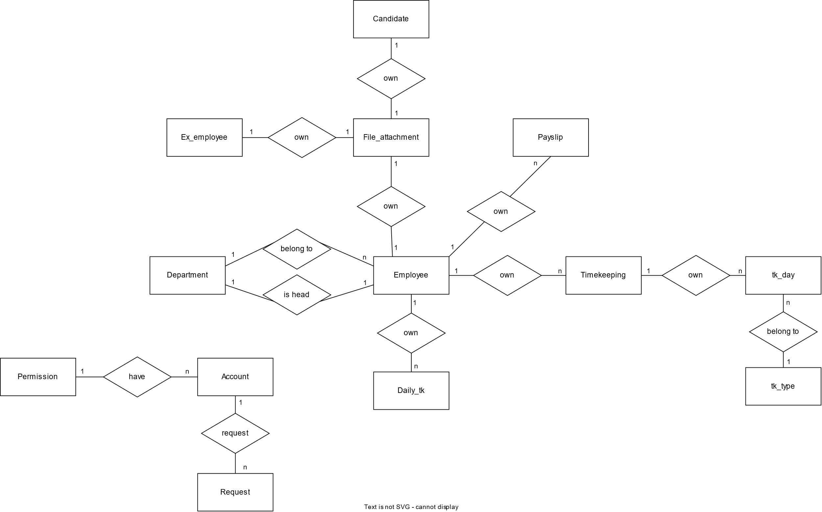

Figure 1. Data model for Personnel Management System.

## Data Dictionary

|  |  |  |  |  |
| --- | --- | --- | --- | --- |
| Data Element | Description | Data Type | Length | Values |
| ***Account*** | | | | |
| Account id | The ID of the account | integer | 6 |  |
| Perms id | The ID of the permission | char | 10 | HR, ACC, BOD, AD |
| Account email | The email that user used to login the PMS | varchar | 50 |  |
| Account password | The password of account | varchar | 50 |  |
| Account name | The name of account’s owner | varchar | 50 |  |
| ***Permission*** | | | | |
| Permission id | The ID of permission type | char | 10 | HR, ACC, BOD, AD |
| Permission name | The name of permission type | varchar | 40 | HR, Accountant, Board of Director, Admin |
| ***Candidate*** | | | | |
| Candidate id | The ID of candidate | varchar | 10 |  |
| Candidate first name | The first name of candidate | varchar | 40 |  |
| Candidate last name | The last name of candidate | varchar | 40 |  |
| CV | The ID of the CV file saved on the file attachment table | integer | 6 |  |
| Apply position | The position that the candidate wants to apply for. | varchar | 50 |  |
| ***File attachment*** | | | | |
| File id | The ID of the file | int | 6 |  |
| File name | The name of the file | varchar | 255 |  |
| File data | The data contained in the file | longblob |  |  |
| ***Request*** | | | | |
| Request id | The ID of the request | char | 10 |  |
| timestamp | The time when the request was sent. | timestamp |  |  |
| BOD id | The account ID of the director who sent this request | AAA-EEE-NNNN xXXXX for area code (A), exchange (E), number (N), and extension (X) | 18 |  |
| payment amount | total price of an order in dollars and cents, calculated per BR-12 | numeric, dollars and cents | dddd.cc |  |
| payment method | how the Patron is paying for a meal he ordered | alphabetic | 16 | payroll deduction, cash, credit card, debit card |
| quantity ordered | the number of units of each food item that the Patron is ordering in a single meal order | integer | 4 | default = 1; maximum = quantity presently in inventory |
| transaction number | unique sequence number that COS assigns to each payment transaction | integer | 12 |  |

## Reports

### Ordered Meal History Report

|  |  |
| --- | --- |
| Report ID: | COS-RPT-1 |
| Report Title: | Ordered Meal History |
| Report Purpose: | Patron wants to see a list of all meals that he had previously ordered from the Process Impact cafeteria or local restaurants over a specified time period up to six months prior to the current date, so he can reorder a particular meal he liked. |
| Priority: | Medium |
| Report Users: | Patrons |
| Data Sources: | Database of previously placed meal orders |
| Frequency and Disposition; | Report is generated on demand by a Patron. Data in the report is static. Report is displayed on user's web browser screen on a computer, tablet, or smartphone. It can be printed if the display device permits printing. |
| Latency: | Complete report must be displayed to Patron within 3 seconds after it is requested. |
| Visual Layout: | Landscape mode |
| Header and Footer: | Report header shall contain the report title, Patron's name, and date range specified. If printed, report footer shall show the page number. |
| Report Body: | Fields shown and column headings:   * Order Number * Meal Date * Ordered From ("Cafeteria" or restaurant name) * Items ordered (list all items in the meal order, their quantity, and their prices) * Total Food Price * Tax * Delivery Charge * Total Price (sum of food item prices, tax, and delivery charge)   Selection Criteria: date range specified by Patron, inclusive of end points  Sort Criteria: reverse chronological order |
| End-of-Report Indicator: | None |
| Interactivity: | Patron can drill down to see ingredients and nutritional information for each item in the order |
| Security Access Restrictions: | A Patron may retrieve only his own meal order history |

[Note: Other COS reports are not provided in this example.]

## Data Integrity, Retention, and Disposal

DI-1: The COS shall retain Individual Patron meal orders for 6 months following the meal's delivery date.

DI-2: The COS shall retain menus for one year following the menu date.

# Internal Interface Requirements

## User Interfaces

## Software Interfaces

## Hardware Interfaces

## Communications Interfaces